

Semester Two Examination, 2019

Question/Answer booklet

MATHEMATICS SPECIALIST
UNIT 2

Section One:

Calculator-free

Your Name_______________________________

Your Teacher’s Name_____________________________

Time allowed for this section
Reading time before commencing work: five minutes
Working time: fifty minutes

Materials required/recommended for this section
To be provided by the supervisor
This Question/Answer booklet
Formula sheet

To be provided by the candidate
Standard items: pens (blue/black preferred), pencils (including coloured), sharpener, correction fluid/tape, eraser, ruler, highlighters

Special items: nil

Important note to candidates
No other items may be taken into the examination room. It is your responsibility to ensure that you do not have any unauthorised material. If you have any unauthorised material with you, hand it to the supervisor before reading any further.
Question | Mark | Max | Question | Mark | Max
1 |  | 3 | 6 |  | 8
2 |  | 6 | 7 |  | 6
3 |  | 7 | 8 |  | 4
4 |  | 8 | 9 |  | 3
5 |  | 7

Structure of this paper

Section | Number of questions available | Number of questions to be answered | Working time (minutes) | Marks available | Percentage of examination
Section One:  Calculator-free | 9 | 9 | 50 | 52 | 36
Section Two:  Calculator-assumed | 13 | 13 | 100 | 94 | 64
 |  |  |  | Total | 100

Instructions to candidates

- The rules for the conduct of the Western Australian Certificate of Education ATAR course examinations are detailed in the Year 12 Information Handbook 2019. Sitting this examination implies that you agree to abide by these rules.

- Write your answers in this Question/Answer booklet.

- You must be careful to confine your answers to the specific questions asked and to follow any instructions that are specific to a particular question.

- Additional pages for the use of planning your answer to a question or continuing your answer to a question have been provided at the end of this Question/Answer booklet. If you use the space to continue an answer, indicate in the original answer space where the answer is continued, i.e. give the page number.

- Show all your working clearly. Your working should be in sufficient detail to allow your answers to be checked readily and for marks to be awarded for reasoning. Incorrect answers given without supporting reasoning cannot be allocated any marks. For any question or part question worth more than two marks, valid working or justification is required to receive full marks. If you repeat any question, ensure that you cancel the answer you do not wish to have marked.

- It is recommended that you do not use pencil, except in diagrams.

- The Formula sheet is not to be handed in with your Question/Answer booklet.

See Next Page

Section One: Calculator-free (52 Marks)

This section has nine (9) questions. Answer all questions. Write your answers in the spaces provided.

Spare pages are included at the end of this booklet. They can be used for planning your responses and/or as additional space if required to continue an answer.
● Planning: If you use the spare pages for planning, indicate this clearly at the top of the page.
● Continuing an answer: If you need to use the space to continue an answer, indicate in the original answer space where the answer is continued, i.e. give the page number. Fill in the number of the question that you are continuing to answer at the top of the page.

Working time: 50 minutes.

Question 1 (3 marks)

Prove the following statement:

If $a$ and $b$ are each 1 less than a multiple of 3, then $ab$ is 1 more than a multiple of 3.

Solution
Assume that $a$ and $b$ are each 1 less than a multiple of 3.
Then $a=3k-1$ and $b=3l-1$ for some $k,l∈Z$.
Hence
$$ab=\left(3k-1\right)\left(3l-1\right) \\ =9kl-3k-3l+1 \\ =3\left(3kl-k-l\right)+1$$
which is 1 more than a multiple of 3 since $3kl-k-l$ is an integer.
QED
Specific behaviours
writes $a$ and $b$ as $3k-1$ and $3l-1$
multiplies and simplifies to $3\left(3kl-k-l\right)+1$
concludes that $ab$ is 1 more than a multiple of $3$

Question 2 (6 marks)

Consider the system of simultaneous linear equations:

$$3x-ay=6 \\ -6x+4y=b$$

- Write down the matrix $A$ such that the equation

$$A\left[\begin{matrix}x \\ y\end{matrix}\right]=\left[\begin{matrix}6 \\ b\end{matrix}\right]$$

is equivalent to the system of equations above. (1 mark)
Solution
$$\left[\begin{matrix}3 & -a \\ -6 & 4\end{matrix}\right]$$
Specific behaviours
writes correct matrix

- Suppose that $A$ is singular (non-invertible).
- Determine the value of $a$ (show working). (2 marks)
Solution
$$A singular⇔\det{A}=0 \\ ⇔3×4-\left(-a\right)\left(-6\right)=0 \\ ⇔a=2$$
Specific behaviours
attempts to solve $\det{A}=0$ for $a$
states correct value

- State the possible number(s) of solutions that the system of equations could have with the value of $a$ you just found. (2 marks)
Solution
Either no solutions or infinitely many solutions.
Specific behaviours
states at least one of ‘no solutions’ and ‘infinitely many solutions’
states both possibilities
No marks if implies that there can be exactly one solution

- State the number of solutions the system has if $a$ has the value found above and $b=11$. (1 mark)

Solution
No solutions.
Specific behaviours
States no solutions.

Question 3 (7 marks)

- Write $3\cos{5x}+3\sqrt{3}\sin{5x}$ in the form $a\sin{(bx+α)}$. (3 marks)
Solution
$$a=\sqrt{3^{2}+{\left(3\sqrt{3}\right)}^{2}} \\ =\sqrt{36} \\ =6 \\ b=5 \\ α=\sin^{-1}\left(\frac{3}{6}\right) \\ =\frac{π}{6}$$
So $3\cos{5x}+3\sqrt{3}\sin{5x}=6\sin\left(5x+\frac{π}{6}\right)$
Specific behaviours
writes correct value for $a$
writes correct value for $b$
writes correct value for $α$

- Hence, solve the equation $3\cos{5x}+3\sqrt{3}\sin{5x}=3\sqrt{3}$ for $-\frac{π}{2}≤x≤\frac{π}{2}$. (4 marks)
Solution
$$3\cos{5x}+3\sqrt{3}\sin{5x}=3\sqrt{3} \\ 6\sin\left(5x+\frac{π}{6}\right)=3\sqrt{3} \\ \sin\left(5x+\frac{π}{6}\right)=\frac{\sqrt{3}}{2} \\ 5x+\frac{π}{6}=\frac{π}{3}+k2π or 5x+\frac{π}{6}=\frac{2π}{3}+k2π, k∈Z \\ x=\frac{π}{30},\frac{13π}{30},-\frac{11π}{30} or x=\frac{π}{10},\frac{5π}{10},-\frac{3π}{10} \\ x=-\frac{11π}{30},-\frac{3π}{10},\frac{π}{30},\frac{π}{10},\frac{13π}{30},\frac{π}{2}$$
Specific behaviours
equates expression from part (a) to $3\sqrt{3}$
obtains at least one general solution (using $\frac{π}{3}$ or $\frac{2π}{3}$) for $5x+\frac{π}{6}$
obtains at least 3 correct solutions for $x$ (in correct domain)
obtains 6 correct solutions for $x$ (in correct domain)

Question 4 (8 marks)

A $2×2$ real matrix $A$ can ‘transform’ a complex number if we view the complex number as a column vector. That is, for any complex number $z=a+bi$, the matrix $A$ transforms $z$ to $c+di$ where $\left[\begin{matrix}c \\ d\end{matrix}\right]=A\left[\begin{matrix}a \\ b\end{matrix}\right]$.

Find the matrix $A$ which (according to this rule) will transform any complex number $z$ to:
- $3z$ (2 marks)
Solution
Multiplication by 3 corresponds to dilation by factor 3.
$$\left[\begin{matrix}3 & 0 \\ 0 & 3\end{matrix}\right]$$
Specific behaviours
identifies corresponding transformation
writes correct matrix

- $\overline{z}$ (2 marks)
Solution
Conjugation corresponds to reflection in $x$-axis.
$$\left[\begin{matrix}1 & 0 \\ 0 & -1\end{matrix}\right]$$
Specific behaviours
identifies corresponding transformation
writes correct matrix

- $iz$ (2 marks)
Solution
Multiplying by $i$ corresponds to rotating anti-clockwise by $90°$.
$$\left[\begin{matrix}0 & -1 \\ 1 & 0\end{matrix}\right]$$
Specific behaviours
identifies corresponding transformation
writes correct matrix

- $i\overline{z}$ (2 marks)

Solution
$$\left[\begin{matrix}0 & -1 \\ 1 & 0\end{matrix}\right]×\left[\begin{matrix}1 & 0 \\ 0 & -1\end{matrix}\right]=\left[\begin{matrix}0 & 1 \\ 1 & 0\end{matrix}\right]$$
Specific behaviours
writes product of matrices OR identifies corresponding transformation sequence
writes correct matrix

Question 5 (7 marks)

Evaluate the following for complex numbers $z=2+5i$ and $w=1-4i$

- $z-w$ (2 marks)
Solution
$$z-w=2+5i-\left(1-4i\right) \\ =1+9i$$
Specific behaviours
writes correct calculation
writes correct answer

- $z(w+\overline{w})$ (2 marks)
Solution
$$z(w+\overline{w})=(2+5i)(1-4i+1+4i) \\ =4+10i$$
Specific behaviours
writes correct expression for conjugate of $w$
writes correct answer

- $\frac{w}{z}$ (3 marks)
Solution
$$\frac{w}{z}=\frac{1-4i}{2+5i} \\ =\frac{\left(1-4i\right)\left(2-5i\right)}{\left(2+5i\right)\left(2-5i\right)} \\ =\frac{2-8i-5i+20i^{2}}{2^{2}+5^{2}} \\ =-\frac{18}{29}-\frac{13}{29}i$$
Specific behaviours
multiplies numerator and denominator by $\overline{w}$
expands numerator and denominator correctly
writes correct answer

Question 6 (8 marks)

In this question, a proper factor is a factor greater than 1.

Assume that $a$ and $b$ are both integers, and consider the following statement:

If $ab$ has no proper square factors, then neither $a$ nor $b$ has a proper square factor.

- Prove the statement using the method of proof by contradiction. (3 marks)
Solution
Assume that $ab$ has no proper square factors, but that either $a$ or $b$ has a proper square factor.
Then either $a=nk^{2}$ or $b=ml^{2}$ for some $k,l,m,n∈Z$.
Hence either $ab=nk^{2}b$ or $ab=a{ml}^{2}$, and in each case $ab$ has a proper square factor.
This is a contradiction, and so neither $a$ nor $b$ has a proper square factor.
Specific behaviours
assumes negation of statement
writes $a$ and/or $b$ as a product of an integer and a square
shows that $ab$ must therefore have a square factor and notes contradiction

Accept argument for $a$ alone having a square factor together with recognition that a similar argument will apply if $b$ has a square factor.

- Write the converse of the statement. (2 marks)
Solution
If neither $a$ nor $b$ has a proper square factor, then $ab$ has no square factors.
Specific behaviours
writes correct converse statement

- Write whether the converse is true or false and prove or disprove it accordingly.
(3 marks)
Solution
False. E.g. if $a=6$ and $b=10$, then neither $a$ nor $b$ has a proper square factor, but $ab=60=2^{2}×15$.
Specific behaviours
states false
gives correct counterexample

Question 7 (6 marks)

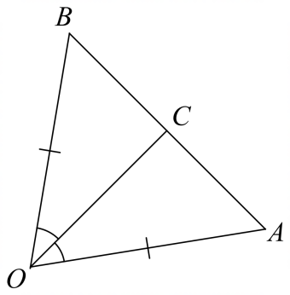
Let $O$ be the origin, let $A$ and $B$ be points such that $OA=OB$, and let $C$ be a point on $\overline{AB}$ such that $\overline{OC}$ bisects $∠AOB$.

Let $a=\vec{OA}$, $b=\vec{OB}$ and $c=\vec{OC}$.

a) Show that $a⋅c=b⋅c$. (3 marks)

Solution
Let $θ=∠COB$. Then $∠COA=θ$.
Now $a⋅c=\left|a\right|\left|c\right|\cos{θ}$ and $b⋅c=\left|b\right|\left|c\right|\cos{θ}$.
Since $\left|a\right|=|b|$ it follows that $a⋅c=b⋅c$.
Specific behaviours
writes expressions for $a⋅c$ and $b⋅c$
uses the fact that $∠COB=∠COA$
uses the fact that $\left|a\right|=|b|$

b) Hence, prove that $\overline{OC}$ is perpendicular to $\overline{AB}$. (3 marks)

Solution
$$\vec{AB}=b-a$$
$$\left(b-a\right)⋅c=b⋅c-a⋅c$$ $=0$ (by part a)
Hence $\overline{AB}$ is perpendicular to $\overline{OC}$.
Specific behaviours
writes $\vec{AB}$ as $b-a$
attempts to determine dot product $\left(b-a\right)⋅c$
shows that $\left(b-a\right)⋅c=0$

Question 8 (4 marks)
Prove the following identity.
$$\frac{\sin{7θ}-\sin{2θ}}{\cos{2θ}+\cos{7θ}}=\tan{\frac{5θ}{2}}$$

Solution
$LHS=\frac{\sin{7θ}-\sin{2θ}}{\cos{2θ}+\cos{7θ}}$$$=\frac{2\sin\left(\frac{5θ}{2}\right)\cos\left(\frac{9θ}{2}\right)}{2\cos\left(\frac{9θ}{2}\right)\cos\left(\frac{5θ}{2}\right)} \\ =\frac{\sin\left(\frac{5θ}{2}\right)}{\cos\left(\frac{5θ}{2}\right)} \\ =\tan\left(\frac{5θ}{2}\right) \\ =RHS$$
Hence LHS = RHS QED
Specific behaviours
rearranges RHS (or LHS) to obtain LHS (or RHS)
correctly uses sum-to-product identities
cancels factor of $2\cos\left(\frac{9θ}{2}\right)$
simplifies to RHS (or LHS)

Question 9 (3 marks)

Let $l$ be a line containing a point $P$, and let $Q$ be a point not on $l$. Suppose that $\hat{n}$ is a unit vector perpendicular to the line $l$. Prove that the perpendicular distance from $Q$ to $l$ is $\left|\vec{PQ}⋅\hat{n}\right|$.

Solution
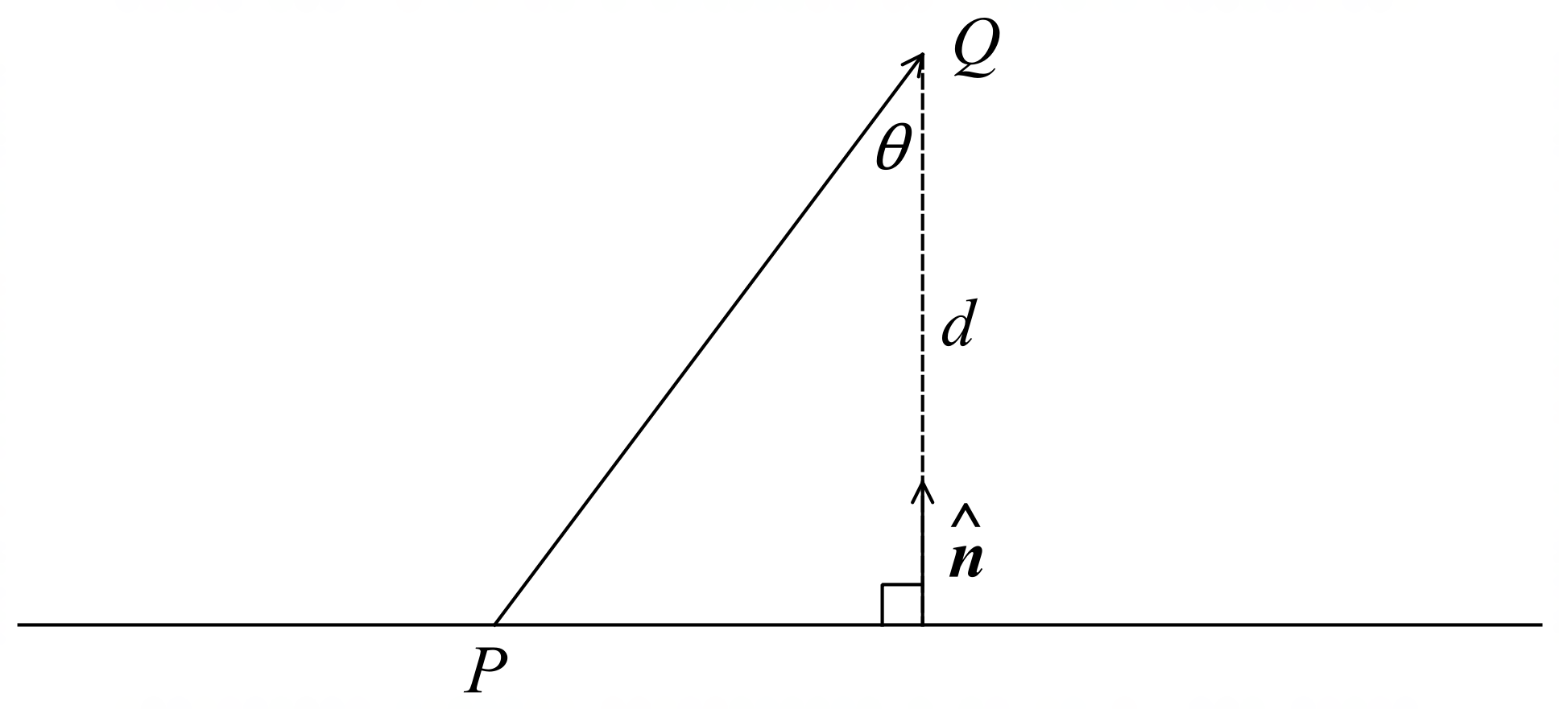

Distance from $Q$ to $l$ is
$$d=\left|\vec{PQ}\right|\cos{θ}$$
$$\vec{PQ}⋅\hat{n}=\left|\vec{PQ}\right|\left|\hat{n}\right|\cos{θ} \\ =\left|\vec{PQ}\right|\cos{θ}$$
Hence $d=\vec{PQ}⋅\hat{n}$ (or $-\vec{PQ}⋅\hat{n}$ if $\hat{n}$ has opposite direction).
Specific behaviours
writes $\vec{PQ}⋅\hat{n}$ as $\left|\vec{PQ}\right|\left|\hat{n}\right|\cos{θ}$
uses the fact that $\left|\hat{n}\right|=1$
uses the fact that the shortest distance from $Q$ to $l$ is $\left|\vec{PQ}\right|\cos{θ}$
(Note that only $d=\vec{PQ}⋅\hat{n}$ is required for marks.)

END OF SECTION ONE
Additional working space
Question number:

Additional working space
Question number:

